QR Codes For Teachers

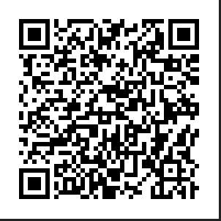
For a tutorial on how to use QR Codes in the classroom visit Vicki Davis' website.
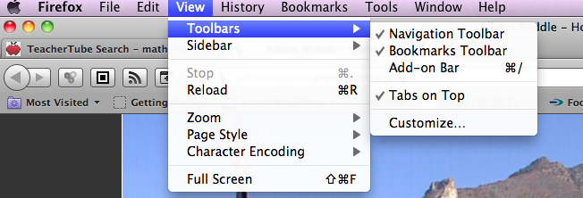
One additional step to add to Vicki's instructions. After adding the Firefox plug-in Barcoder, go to your toolbar in Firefox. Click view, and select Toolbars. On the pull down menu highlight customize

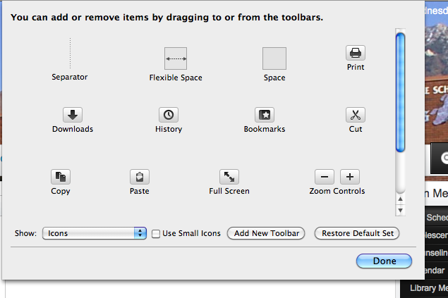

Next you will see several options in a box.

Drag the little box icon from the options box up near the address window.

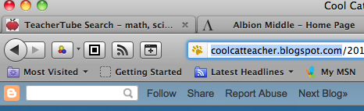

When you want to create a QR Code for a website ot a you tube video, go to the website and double click the little icon you dragged up near the address bar. A new window will open with just the QR code in it. You will want to take a screen shot of just the code. Hold down the following four keys on your keyboard. shift, control, command and 4. Your cursor will change into cross hairs. Move the cross hairs to the upper left corner of the code. Click with your mouse and drag a box around the code. Open a word document and paste the code into the document. The code can now be printed and placed on the wall, door or anywhere else you want to put it. The code can also be placed into a powerpoint presentation and students can scan it while it is being projected onto your screen in your classroom.

